**Appendix I: Garden Peninsula, Michigan, Lake Michigan**

This appendix provides information on the numbers and information used in selecting the Garden Peninsula, Michigan, portion of Lake Michigan as a Sea Duck Joint Venture key habitat site. All aerial survey data were collected during a project led by Kevin Kenow (U.S. Geological Survey, Upper Midwest Environmental Sciences Center, La Crosse, Wisconsin; Kenow et al. 2021). Additional information that assisted in designating key site boundaries, especially those consisting mainly of Long-tailed Ducks, comes from descriptions of habitat use and movements of Long-tailed Ducks (*Clangula hyemalis*) radio-marked on Lake Michigan provided by Fara (2018).

**Brief Description of Aerial Surveys**

Aerial surveys were conducted during September through May 2009 through 2014. Survey areas were selected to evaluate avian risk to type E botulism and to provide information on waterbird distributions to inform offshore wind energy development. Timing and selection of areas to be surveyed in a given month were focused on these issues and were highly influenced by plane availability and weather conditions. Surveys were flown along fixed-width transects. Transects generally paralleled shorelines and extended up to 32 km (20 mi) offshore. Surveys were flown at an average air speed of about 200 km/h (125 mph) and at an altitude of about 61 to 76 m (200 to 250 ft) above the water using a U.S. Fish and Wildlife Service (USFWS) fixed-wing aircraft (Partenavia P.68 Observer[1]). Two observers, one on each side of the plane, identified and tallied waterbirds within 200 m wide (1/8-mi) strip transects on either side of the plane. Distances were established using a clinometer, and the portion of the transect band beneath the plane that was not observable was estimated at 70.4 m (35.2 x 2) and 88 m (44 x2) at 61 and 76 m above ground level (AGL), respectively.

**Brief Description of Appendix Contents**

This appendix contains nine tables and three figures. Tables S1, S4, and S7 provide the raw counts of sea ducks observed on (within the 200 m transect) and off (beyond the 200 m transect) transect for the surveys that were encompassed by the Garden Peninsula, Michigan, Lake Michigan key site during fall (September–November), winter (December–February), and spring (March–May), respectively. Raw counts do not account for the visibility factors that may affect bird detectability during aerial surveys; therefore, we estimated the number of sea ducks using a visibility correction factor (Hodges et al. 2008) and present those numbers in tables S2, S5, and S8 for fall, winter, and spring, respectively. Tables S3, S6, and S9 provide the transect distance, observed area within the 200-m transect width at 61 m AGL, and the density of all sea ducks for both the raw and visibility-corrected counts for fall, winter, and spring, respectively. Figures 1, 2, and 3 illustrate the distribution of sea ducks by month for the fall, winter, and spring seasons, respectively. In addition, all figures outline the aerial survey areas encompassed by the Garden Peninsula, Michigan, Lake Michigan key site.

**References**

Fara, L. J. 2018. Migration patterns, habitat use, prey items, and hunter harvest of Long-tailed Ducks (*Clangula hyemalis*) that overwinter on Lake Michigan. MS thesis, Southern Illinois University Carbondale, Carbondale, Illinois.

Hodges, J. I., D. J. Groves, and B. P. Conant. 2008. Distribution and abundance of waterbirds near shore in Southeast Alaska. Northwestern Naturalist 89:85–96.

Kenow, K. P., Fox, T. J., Houdek, S. C., Fara, L. J., and Lubinski, B. 2021. Lake Michigan Sea Duck Survey Data, 2009-2014: U.S. Geological Survey data release, <https://doi.org/10.5066/P9FGR77R> .

Table S1. Raw counts of sea ducks, by species,1 observed on and off transect during aerial surveys conducted over Lake Michigan during fall (September–November). Survey areas listed are only those encompassed by the Garden Peninsula, Michigan, Lake Michigan key site.

|  |  |  |  |  |  |  |  |  |  |  |  |  |  |  |
| --- | --- | --- | --- | --- | --- | --- | --- | --- | --- | --- | --- | --- | --- | --- |
| Survey area | Survey date | On/Off transect | LTDU | WWSC | BLSC | SUSC | SCOT | COME | RBME | HOME | MERG | COGO | BUFF | **Total sea ducks** |
| Door County–Garden Peninsula | 16–17 Sep 2010 | On | 0 | 18 | 0 | 0 | 0 | 24 | 0 | 0 | 0 | 0 | 0 | **42** |
| Off | 0 | 1 | 0 | 0 | 0 | 60 | 0 | 0 | 0 | 0 | 0 | **61** |
| Door County–Garden Peninsula | 7–8 Oct 2010 | On | 36 | 28 | 0 | 0 | 0 | 476 | 0 | 0 | 0 | 0 | 0 | **540** |
| Off | 0 | 0 | 0 | 0 | 0 | 0 | 0 | 0 | 0 | 0 | 0 | **0** |
| Door County–Garden Peninsula | 9–11 Nov 2010 | On | 848 | 406 | 0 | 0 | 0 | 287 | 9 | 0 | 0 | 52 | 153 | **1,755** |
| Off | 75 | 0 | 0 | 0 | 0 | 0 | 0 | 0 | 0 | 0 | 0 | **75** |
| Door County–Garden Peninsula | 13 Sep 2011 | On | 80 | 0 | 0 | 0 | 0 | 281 | 0 | 0 | 0 | 0 | 0 | **361** |
| Off | 0 | 0 | 0 | 0 | 0 | 0 | 0 | 0 | 0 | 0 | 0 | **0** |
| Door County–Garden Peninsula | 5 Oct 2011 | On | 0 | 2 | 0 | 0 | 0 | 27 | 0 | 0 | 0 | 4 | 0 | **33** |
| Off | 0 | 0 | 0 | 0 | 0 | 0 | 0 | 0 | 0 | 0 | 0 | **0** |
| Door County–Garden Peninsula | 27 Sep 2012 | On | 0 | 0 | 0 | 0 | 2 | 0 | 20 | 0 | 15 | 0 | 0 | **37** |
| Off | 0 | 0 | 0 | 0 | 0 | 0 | 0 | 0 | 0 | 0 | 0 | **0** |
| Door County–Garden Peninsula | 29 Nov 2012 | On | 583 | 4 | 57 | 0 | 0 | 69 | 9 | 0 | 213 | 36 | 1 | **972** |
| Off | 0 | 0 | 0 | 0 | 0 | 0 | 0 | 0 | 0 | 0 | 0 | **0** |
| Door County–Garden Peninsula | 17–18 Sep 2013 | On | 0 | 0 | 0 | 0 | 0 | 44 | 0 | 0 | 32 | 0 | 0 | **76** |
| Off | 0 | 0 | 0 | 0 | 0 | 0 | 0 | 0 | 0 | 0 | 0 | **0** |
| Door County–Garden Peninsula | 23–24 Oct 2013 | On | 90 | 0 | 0 | 0 | 21 | 20 | 123 | 0 | 130 | 12 | 0 | **396** |
| Off | 0 | 0 | 0 | 0 | 0 | 0 | 0 | 0 | 0 | 0 | 0 | **0** |
| Manistique Bay2 | 16 Sep 2014 | On | 0 | 6 | 0 | 0 | 0 | 0 | 3 | 0 | 57 | 2 | 0 | **68** |
| Off | 0 | 0 | 0 | 0 | 0 | 0 | 0 | 0 | 0 | 0 | 0 | **0** |
| Manistique Bay2 | 21 Oct 2014 | On | 4686 | 4 | 0 | 0 | 5 | 0 | 68 | 0 | 44 | 0 | 0 | **4807** |
| Off | 925 | 0 | 0 | 0 | 0 | 0 | 0 | 0 | 0 | 0 | 0 | **0** |
| **Total Garden Peninsula**  **Lake Michigan key site** | | **On** | **6323** | **468** | **57** | **0** | **28** | **1228** | **232** | **0** | **491** | **106** | **154** | **9087** |
| **Off** | **1000** | **1** | **0** | **0** | **0** | **60** | **0** | **0** | **0** | **0** | **0** | **925** |

1 LTDU = Long-tailed Duck (*Clangula hyemalis*), WWSC = White-winged Scoter *(Melanitta deglandi*), BLSC = Black Scoter (*Melanitta americana*), SUSC = Surf Scoter (*Melanitta perspicillata*), SCOT = unidentified scoter species, COME = Common Merganser (*Mergus merganser*), RBME = Red-breasted Merganser (*Mergus serrator*), HOME = Hooded Merganser (*Lophodytes cucullatus*), MERG = unidentified merganser species, COGO = Common Goldeneye (*Bucephala clangula*), and BUFF = Bufflehead (*Bucephala albeola*).

2 Manistique Bay is a shortened version of the Door County–Garden Peninsula survey. Transects start at the southern end of the Garden Peninsula and run north, parallel to the peninsula.

Table S2. Estimated counts of sea ducks, by species or species groups,1 observed on and off transect during aerial surveys conducted over Lake Michigan during fall (September–November) using a visibility correction factor (Hodges et al. 2008). Correction factor multipliers are shown in parentheses under each species or species group. Survey areas listed are only those encompassed by the Garden Peninsula, Michigan, Lake Michigan key site.

|  |  |  |  |  |  |  |  |  |
| --- | --- | --- | --- | --- | --- | --- | --- | --- |
| Survey area | Survey date | On/Off transect | LTDU  (3.46) | SCOTERS  (1.74) | MERGANSERS  (1.45) | COGO  (1.60) | BUFF  (3.26) | **Total sea ducks** |
| Door County–Garden Peninsula | 16–17 Sep 2010 | On | 0 | 31 | 35 | 0 | 0 | **66** |
| Off | 0 | 2 | 87 | 0 | 0 | **89** |
| Door County–Garden Peninsula | 7–8 Oct 2010 | On | 125 | 49 | 690 | 0 | 0 | **863** |
| Off | 0 | 0 | 0 | 0 | 0 | **0** |
| Door County–Garden Peninsula | 9–11 Nov 2010 | On | 2934 | 706 | 429 | 83 | 499 | **4562** |
| Off | 260 | 0 | 0 | 0 | 0 | **260** |
| Door County–Garden Peninsula | 13 Sep 2011 | On | 277 | 0 | 407 | 0 | 0 | **684** |
| Off | 0 | 0 | 0 | 0 | 0 | **0** |
| Door County–Garden Peninsula | 5 Oct 2011 | On | 0 | 3 | 39 | 6 | 0 | **49** |
| Off | 0 | 0 | 0 | 0 | 0 | **0** |
| Door County–Garden Peninsula | 27 Sep 2012 | On | 0 | 3 | 51 | 0 | 0 | **54** |
| Off | 0 | 0 | 0 | 0 | 0 | **0** |
| Door County–Garden Peninsula | 29 Nov 2012 | On | 2017 | 106 | 422 | 58 | 3 | **2606** |
| Off | 0 | 0 | 0 | 0 | 0 | **0** |
| Door County–Garden Peninsula | 17–18 Sep 2013 | On | 0 | 0 | 110 | 0 | 0 | **110** |
| Off | 0 | 0 | 0 | 0 | 0 | **0** |
| Door County–Garden Peninsula | 23–24 Oct 2013 | On | 311 | 37 | 396 | 19 | 0 | **763** |
| Off | 0 | 0 | 0 | 0 | 0 | **0** |
| Manistique Bay2 | 16 Sep 2014 | On | 0 | 10 | 87 | 3 | 0 | **101** |
| Off | 0 | 0 | 0 | 0 | 0 | **0** |
| Manistique Bay2 | 21 Oct 2014 | On | 16,214 | 16 | 162 | 0 | 0 | **16,392** |
| Off | 3201 | 0 | 0 | 0 | 0 | **3201** |
| **Total Garden Peninsula**  **Lake Michigan key site** | | **On** | **21,878** | **961** | **2828** | **169** | **502** | **26,340** |
| **Off** | **3461** | **2** | **87** | **0** | **0** | **3550** |

1 LTDU = Long-tailed Duck (*Clangula hyemalis*), SCOTERS = Scoter species, MERGANSER = Merganser species, COGO = Common Goldeneye (*Bucephala clangula*), and BUFF = Bufflehead (*Bucephala albeola*).

2 Manistique Bay is a shortened version of the Door County–Garden Peninsula survey. Transects start at the southern end of the Garden Peninsula and run north, parallel to the peninsula.

Table S3. Fall (September–November) density estimates for all sea ducks combined using both raw counts and visibility corrected (Hodges et al. 2008) count estimates for observations on transect. Survey areas listed are only those encompassed by the Garden Peninsula, Michigan, Lake Michigan key site.

|  |  |  |  |  |  |
| --- | --- | --- | --- | --- | --- |
| Survey area | Survey date | Transect distance (km) | Transect area (km2) at 61 m AGL | Raw count density  (sea ducks/km2) | Corrected count density  (sea ducks/km2) |
| Door County–Garden Peninsula | 16–17 Sep 2010 | 584.3 | 192.6 | 0.2 | 0.3 |
| Door County–Garden Peninsula | 7–8 Oct 2010 | 974.4 | 321.2 | 1.7 | 2.7 |
| Door County–Garden Peninsula | 9–11 Nov 2010 | 961.0 | 316.7 | 5.5 | 14.7 |
| Door County–Garden Peninsula | 13 Sep 2011 | 916.7 | 302.1 | 1.2 | 2.3 |
| Door County–Garden Peninsula | 5 Oct 2011 | 970.6 | 319.9 | 0.1 | 0.2 |
| Door County–Garden Peninsula | 27 Sep 2012 | 607.9 | 200.4 | 0.2 | 0.3 |
| Door County–Garden Peninsula | 29 Nov 2012 | 420.3 | 138.5 | 7.0 | 18.8 |
| Door County–Garden Peninsula | 17–18 Sep 2013 | 558.6 | 184.1 | 0.4 | 0.6 |
| Door County–Garden Peninsula | 23–24 Oct 2013 | 424.3 | 139.8 | 2.8 | 5.5 |
| Manistique Bay1 | 16 Sep 2014 | 551.7 | 181.8 | 0.4 | 0.6 |
| Manistique Bay1 | 21 Oct 2014 | 550.5 | 181.4 | 26.5 | 90.4 |
| **Total Garden Peninsula**  **Lake Michigan key site** | | **7520.3** | **2478.6** | **3.7** | **10.6** |

1 Manistique Bay is a shortened version of the Door County–Garden Peninsula survey. Transects start at the southern end of the Garden Peninsula and run north, parallel to the peninsula.

Table S4. Raw counts of sea ducks, by species1, observed on and off transect during aerial surveys conducted over Lake Michigan during winter (December–February). Survey areas listed are only those encompassed by the Garden Peninsula, Michigan, Lake Michigan key site.

|  |  |  |  |  |  |  |  |  |  |  |  |  |  |  |
| --- | --- | --- | --- | --- | --- | --- | --- | --- | --- | --- | --- | --- | --- | --- |
| Survey area | Survey date | On/Off transect | LTDU | WWSC | BLSC | SUSC | SCOT | COME | RBME | HOME | MERG | COGO | BUFF | **Total sea ducks** |
| Door County–Garden Peninsula | 13 Jan 2011 | On | 1023 | 10 | 0 | 0 | 0 | 2454 | 73 | 0 | 0 | 239 | 14 | **3813** |
| Off | 130 | 0 | 0 | 0 | 0 | 0 | 0 | 0 | 0 | 0 | 0 | **130** |
| Door County–Garden Peninsula | 6 Dec 2011 | On | 1582 | 0 | 0 | 0 | 24 | 83 | 3 | 0 | 20 | 14 | 6 | **1732** |
| Off | 675 | 0 | 0 | 0 | 0 | 0 | 0 | 0 | 0 | 0 | 0 | **675** |
| Door County–Garden Peninsula | 14 Feb 2012 | On | 179 | 5 | 0 | 0 | 0 | 227 | 119 | 0 | 27 | 238 | 17 | **812** |
| Off | 0 | 0 | 0 | 0 | 0 | 0 | 0 | 0 | 0 | 0 | 0 | **0** |
| **Total Garden Peninsula**  **Lake Michigan key site** | | **On** | **2784** | **15** | **0** | **0** | **24** | **2764** | **195** | **0** | **47** | **491** | **37** | **6357** |
| **Off** | **805** | **0** | **0** | **0** | **0** | **0** | **0** | **0** | **0** | **0** | **0** | **805** |

1 LTDU = Long-tailed Duck (*Clangula hyemalis*), WWSC = White-winged Scoter *(Melanitta deglandi*), BLSC = Black Scoter (*Melanitta americana*), SUSC = Surf Scoter (*Melanitta perspicillata*), SCOT = unidentified scoter species, COME = Common Merganser (*Mergus merganser*), RBME = Red-breasted Merganser (*Mergus serrator*), HOME = Hooded Merganser (*Lophodytes cucullatus*), MERG = unidentified merganser species, COGO = Common Goldeneye (*Bucephala clangula*), and BUFF = Bufflehead (*Bucephala albeola*).

Table S5. Estimated counts of sea ducks, by species or species groups,1 observed on and off transect during aerial surveys conducted over Lake Michigan during winter (December–February) using a visibility correction factor (Hodges et al. 2008). Correction factor multipliers are shown in parentheses under each species or species group. Survey areas listed are only those encompassed by the Garden Peninsula, Michigan, Lake Michigan key site.

|  |  |  |  |  |  |  |  |  |
| --- | --- | --- | --- | --- | --- | --- | --- | --- |
| Survey area | Survey date | On/Off transect | LTDU  (3.46) | SCOTERS  (1.74) | MERGANSERS  (1.45) | COGO  (1.60) | BUFF  (3.26) | **Total sea ducks** |
| Door County–Garden Peninsula | 13 Jan 2011 | On | 3540 | 17 | 3664 | 382 | 46 | **7649** |
| Off | 450 | 0 | 0 | 0 | 0 | **450** |
| Door County–Garden Peninsula | 6 Dec 2011 | On | 5474 | 42 | 154 | 22 | 20 | **5711** |
| Off | 2336 | 0 | 0 | 0 | 0 | **2336** |
| Door County–Garden Peninsula | 14 Feb 2012 | On | 619 | 9 | 541 | 381 | 55 | **1605** |
| Off | 0 | 0 | 0 | 0 | 0 | **0** |
| **Total Garden Peninsula**  **Lake Michigan key site** | | **On** | **9633** | **68** | **4359** | **785** | **121** | **14,965** |
| **Off** | **2786** | **0** | **0** | **0** | **0** | **2786** |

1 LTDU = Long-tailed Duck (*Clangula hyemalis*), SCOTERS = Scoter species, MERGANSER = Merganser species, COGO = Common Goldeneye (*Bucephala clangula*), and BUFF = Bufflehead (*Bucephala albeola*).

Table S6. Winter (December–February) density estimates for all sea ducks combined using both raw counts and visibility corrected (Hodges et al. 2008) count estimates for observations on transect. Survey areas listed are only those encompassed by the Garden Peninsula, Michigan, Lake Michigan key site.

|  |  |  |  |  |  |
| --- | --- | --- | --- | --- | --- |
| Survey area | Survey date | Transect distance (km) | Transect area (km2) at 61 m AGL | Raw count density  (sea ducks/km2) | Corrected count density  (sea ducks/km2) |
| Door County–Garden Peninsula | 13 Jan 2011 | 876.2 | 288.8 | 13.2 | 26.5 |
| Door County–Garden Peninsula | 6 Dec 2011 | 702.7 | 231.6 | 7.5 | 24.7 |
| Door County–Garden Peninsula | 14 Feb 2012 | 433.4 | 142.8 | 5.7 | 11.2 |
| **Total Garden Peninsula**  **Lake Michigan key site** | | **2012.3** | **663.2** | **9.6** | **22.6** |

Table S7. Raw counts of sea ducks, by species,1 observed on and off transect during aerial surveys conducted over Lake Michigan during spring (March–May). Survey areas listed are only those encompassed by the Garden Peninsula, Michigan, Lake Michigan key site.

|  |  |  |  |  |  |  |  |  |  |  |  |  |  |  |
| --- | --- | --- | --- | --- | --- | --- | --- | --- | --- | --- | --- | --- | --- | --- |
| Survey area | Survey date | On/Off transect | LTDU | WWSC | BLSC | SUSC | SCOT | COME | RBME | HOME | MERG | COGO | BUFF | **Total sea ducks** |
| Door County–Garden Peninsula | 8 Apr 2011 | On | 7475 | 2 | 0 | 0 | 0 | 489 | 0 | 0 | 0 | 402 | 5 | **8373** |
| Off | 2100 | 0 | 0 | 0 | 0 | 0 | 0 | 0 | 0 | 0 | 0 | **2100** |
| Door County–Garden Peninsula | 5 Apr 2012 | On | 47 | 1 | 0 | 0 | 0 | 538 | 226 | 0 | 96 | 59 | 3 | **970** |
| Off | 0 | 0 | 0 | 0 | 0 | 0 | 0 | 0 | 0 | 0 | 0 | **0** |
| **Total Garden Peninsula**  **Lake Michigan key site** | | **On** | **7522** | **3** | **0** | **0** | **0** | **1027** | **226** | **0** | **96** | **461** | **8** | **9343** |
| **Off** | **2100** | **0** | **0** | **0** | **0** | **0** | **0** | **0** | **0** | **0** | **0** | **2100** |

1 LTDU = Long-tailed Duck (*Clangula hyemalis*), WWSC = White-winged Scoter *(Melanitta deglandi*), BLSC = Black Scoter (*Melanitta americana*), SUSC = Surf Scoter (*Melanitta perspicillata*), SCOT = unidentified scoter species, COME = Common Merganser (*Mergus merganser*), RBME = Red-breasted Merganser (*Mergus serrator*), HOME = Hooded Merganser (*Lophodytes cucullatus*), MERG = unidentified merganser species, COGO = Common Goldeneye (*Bucephala clangula*), and BUFF = Bufflehead (*Bucephala albeola*).

Table S8. Estimated counts of sea ducks, by species or species groups,1 observed on and off transect during aerial surveys conducted over Lake Michigan during spring (March–May) using a visibility correction factor (Hodges et al. 2008). Correction factor multipliers are shown in parentheses under each species or species group. Survey areas listed are only those encompassed by the Garden Peninsula, Michigan, Lake Michigan key site.

|  |  |  |  |  |  |  |  |  |
| --- | --- | --- | --- | --- | --- | --- | --- | --- |
| Survey area | Survey date | On/Off transect | LTDU  (3.46) | SCOTERS  (1.74) | MERGANSERS  (1.45) | COGO  (1.60) | BUFF  (3.26) | **Total sea ducks** |
| Door County–Garden Peninsula | 8 Apr 2011 | On | 25,864 | 3 | 709 | 643 | 16 | **27,236** |
| Off | 7266 | 0 | 0 | 0 | 0 | **7266** |
| Door County–Garden Peninsula | 5 Apr 2012 | On | 163 | 2 | 1247 | 94 | 10 | **1516** |
| Off | 0 | 0 | 0 | 0 | 0 | **0** |
| **Total Garden Peninsula**  **Lake Michigan key site** | | **On** | **26,027** | **5** | **1956** | **737** | **26** | **28,752** |
| **Off** | **7266** | **0** | **0** | **0** | **0** | **7266** |

1 LTDU = Long-tailed Duck (*Clangula hyemalis*), SCOTERS = Scoter species, MERGANSER = Merganser species, COGO = Common Goldeneye (*Bucephala clangula*), and BUFF = Bufflehead (*Bucephala albeola*).

Table S9. Spring (March–May) density estimates for all sea ducks combined using both raw counts and visibility corrected (Hodges et al. 2008) count estimates for observations on transect. Survey areas listed are only those encompassed by the Garden Peninsula, Michigan, Lake Michigan key site.

|  |  |  |  |  |  |
| --- | --- | --- | --- | --- | --- |
| Survey area | Survey date | Transect distance (km) | Transect area (km2) at 61 m AGL | Raw count density  (sea ducks/km2) | Corrected count density  (sea ducks/km2) |
| Door County–Garden Peninsula | 8 Apr 2011 | 870.9 | 287.0 | 29.2 | 94.9 |
| Door County–Garden Peninsula | 5 Apr 2012 | 432.6 | 142.6 | 6.8 | 10.6 |
| **Total Garden Peninsula**  **Lake Michigan key site** | | **1303.5** | **429.6** | **21.7** | **66.9** |

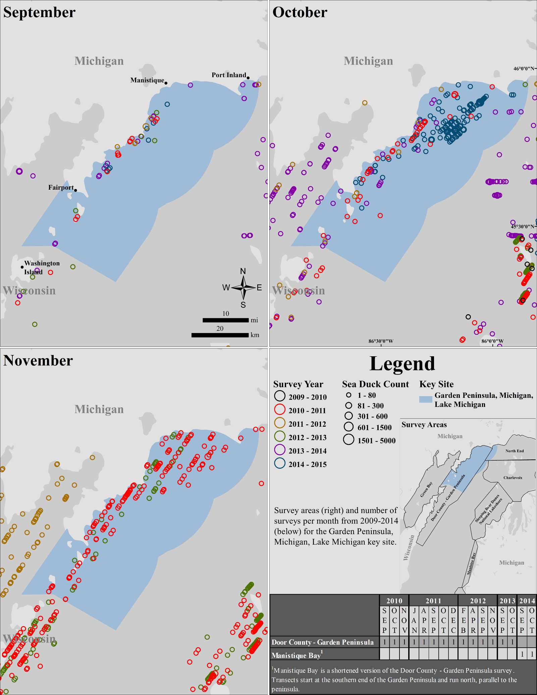

Figure S1. Maps depict sea duck counts from aerial surveys conducted over Lake Michigan from 2009–2014 during fall (September–November) for the Garden Peninsula, Michigan, Lake Michigan key site, by month.

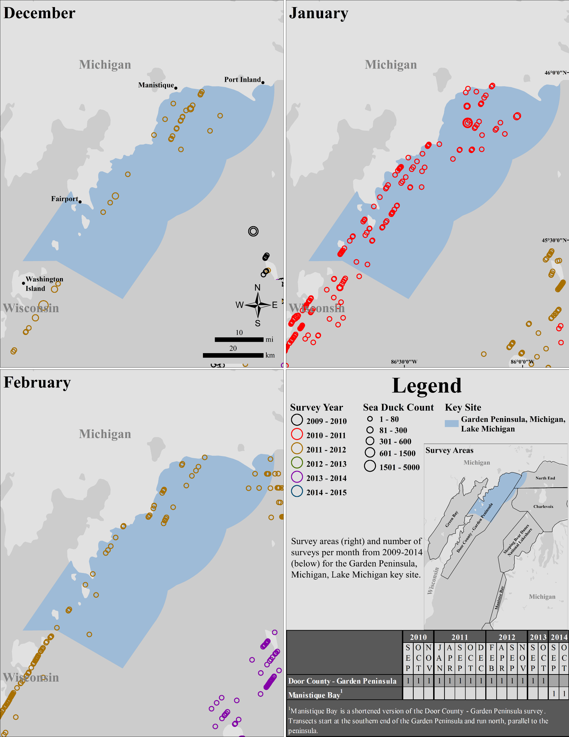

Figure S2. Maps depict sea duck counts from aerial surveys conducted over Lake Michigan from 2009–2014 during winter (December–February) for the Garden Peninsula, Michigan, Lake Michigan key site, by month.

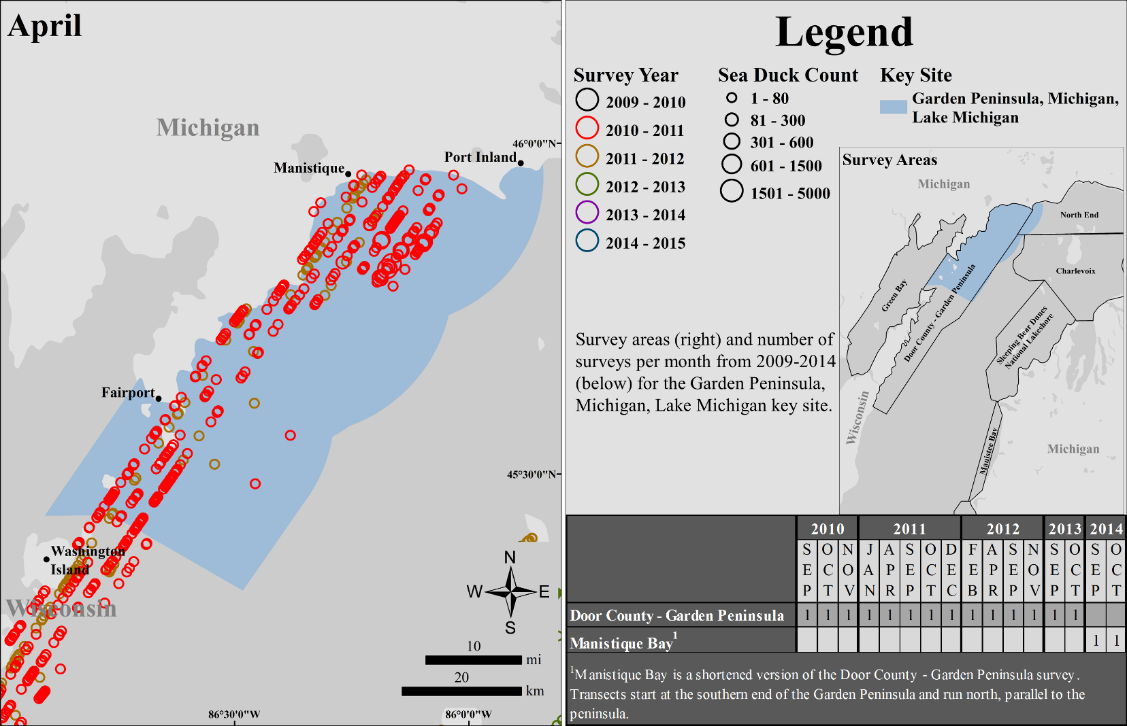

Figure S3. Maps depict sea duck counts from aerial surveys conducted over Lake Michigan from 2009–2014 during spring (March–May) for the Garden Peninsula, Michigan, Lake Michigan key site, by month. March and May are not depicted as no surveys were conducted in this key site during those months.

1. Any use of trade, firm, or product names is for descriptive purposes only and does not imply endorsement by the U.S. government.