**Appendix I – Green Bay, Wisconsin, and Bay de Nocs, Michigan**

This appendix provides information on the numbers and information used in selecting the Green Bay, Wisconsin, and Bay de Nocs, Michigan, portion of Lake Michigan as a Sea Duck Joint Venture key habitat site. Aerial survey data were collected during a project led by Kevin Kenow (U.S. Geological Survey Upper Midwest Environmental Sciences Center, La Crosse, Wisconsin; Kenow et al. 2021) and surveys conducted by the Wisconsin Department of Natural Resources (DNR; Wisconsin DNR 2019). Additional information that assisted in designating key site boundaries comes from descriptions of habitat use and movements of Long-tailed Ducks (*Clangula hyemalis*) radiomarked on Lake Michigan provided by Fara (2018).

**Brief Description of U.S. Geological Survey Aerial Surveys**

Aerial surveys were conducted during September through May, 2009 through 2014. Survey areas were selected to evaluate avian risk from type E botulism and to provide information on waterbird distributions to inform offshore wind energy development. Timing and selection of areas to be surveyed in a given month were focused on these issues and were highly influenced by plane availability and weather conditions. Surveys were flown along fixed-width transects. Transects generally paralleled shorelines and extended up to 32 km (20 mi) offshore. Surveys were flown at an average air speed of about 200 km/h (125 mph) and at an altitude of about 61–76 m (200–250 ft) above the water using a U.S. Fish and Wildlife Service (USFWS) fixed-wing aircraft (Partenavia P.68 Observer[1]). Two observers, one on each side of the plane, identified and tallied all waterbirds within 200-m wide (1/8-mi) strip transects on either side of the plane. Distances were established using a clinometer, and the portion of the transect band beneath the plane that was not observable was estimated at 70.4 m (35.2 x 2) and 88 m (44 x2) at 61 and 76 m above ground level (AGL), respectively.

**Brief Description of Wisconsin Department of Natural Resources Aerial Surveys**

Aerial surveys were conducted in November and December 2017 and November 2018 to document waterfowl use in the southern portion of Green Bay (i.e., Lower Green Bay). The survey consisted of two transects, 0.8 km (0.5 mi) and 2.4 km (1.5 mi) offshore, that followed the Wisconsin shoreline from the Sturgeon Bay canal to the Wisconsin/Michigan border. Surveys were flown at an average air speed of about 165 km/h (103 mph) and at an altitude of 61 m (200 ft) above the water using a Wisconsin DNR fixed-wing aircraft (Cessna Skymaster 3371). Two observers, one on each side of the plane, identified and tallied waterfowl within 402 m (0.25 mi) strip transects on either side of the plane. The portion of the transect band beneath the plane that was not observable was estimated as 70.4 m (35.2 m x 2) at 61 m AGL. Spatial data were not collected during these surveys; thus, no distribution maps are provided for these data.

**Brief Description of Appendix Contents**

This appendix contains six tables and one figure. Tables S1 and S4 provide the raw counts of sea ducks observed on (within the 200 m transect [U.S. Geological Survey] or within the 402 m transect [Wisconsin DNR]) and off (beyond the 200 m transect [U.S. Geological Survey]) transect for the surveys that were encompassed by the Green Bay, Wisconsin, and Bay de Nocs, Michigan, key site during fall (September–November) and winter (December–February), respectively. Raw counts do not account for the visibility factors that may affect bird detectability during aerial surveys; therefore, we estimated the number of sea ducks using a visibility correction factor (Hodges et al. 2008) and present those numbers in tables S2 and S5 for fall and winter, respectively. Tables S3 and S6 provide the transect distance (estimated for Wisconsin DNR surveys), observed area within the 200 m transect width at 61 m AGL (U.S. Geological Survey) or area within the 402 m transect width at 61 m AGL (Wisconsin DNR), and the density of all sea ducks for both the raw and visibility-corrected counts for fall and winter, respectively. Figure 1 illustrates the distribution of sea ducks by month during fall (September–November) and outlines the aerial survey areas encompassed by the Green Bay, Wisconsin, and Bay de Nocs, Michigan, key site. Spatial count data are only available for U.S. Geological Survey data, thus only the approximated transects flown by the Wisconsin DNR are presented within the figure. Spring surveys are lacking for this site, as neither U.S. Geological Survey nor Wisconsin DNR conducted spring surveys within this key site. However, radiomarked Long-tailed Ducks indicated that this area is important during spring (Fara 2018), and anecdotal observations provided by fisherman and biologists indicate that large numbers of sea ducks are using this area during spring from ice out through early May.

**References**

Fara, L. J. 2018. Migration patterns, habitat use, prey items, and hunter harvest of Long-tailed Ducks (*Clangula hyemalis*) that overwinter on Lake Michigan. MS thesis, Southern Illinois University Carbondale, Carbondale, Illinois.

Hodges, J. I., D. J. Groves, and B. P. Conant. 2008. Distribution and abundance of waterbirds near shore in Southeast Alaska. Northwestern Naturalist 89:85–96.

Kenow, K. P., Fox, T. J., Houdek, S. C., Fara, L. J., and Lubinski, B. 2021. Lake Michigan Sea Duck Survey Data, 2009-2014: U.S. Geological Survey data release, <https://doi.org/10.5066/P9FGR77R> .

Wisconsin DNR. 2019. Wisconsin Waterfowl Surveys. <https://dnr.wi.gov/topic/WildlifeHabitat/wfsurveys.html>

Table S1. Raw counts of sea ducks, by species1, observed on and off transect during aerial surveys conducted over Lake Michigan during fall (September – November). Survey areas listed are only those encompassed by the Green Bay, Wisconsin, and Bay de Nocs, Michigan, key site.

|  |  |  |  |  |  |  |  |  |  |  |  |  |  |  |
| --- | --- | --- | --- | --- | --- | --- | --- | --- | --- | --- | --- | --- | --- | --- |
| Survey area | Survey date | On/Off transect | LTDU | WWSC | BLSC | SUSC | SCOT | COME | RBME | HOME | MERG | COGO | BUFF | **Total sea ducks** |
| Green Bay2 | 12–13 Sep 2011 | On | 0 | 0 | 0 | 0 | 0 | 0 | 0 | 0 | 0 | 0 | 0 | **0** |
| Off | 0 | 0 | 0 | 0 | 0 | 0 | 0 | 0 | 0 | 0 | 0 | **0** |
| Green Bay2 | 5–6 Oct 2011 | On | 0 | 1 | 0 | 0 | 0 | 229 | 2 | 0 | 0 | 0 | 0 | **232** |
| Off | 0 | 0 | 0 | 0 | 0 | 0 | 0 | 0 | 0 | 0 | 0 | **0** |
| Green Bay2 | 17 Nov 2011 | On | 297 | 15 | 0 | 0 | 0 | 455 | 59 | 0 | 138 | 38 | 0 | **1002** |
| Off | 0 | 0 | 0 | 0 | 0 | 2500 | 0 | 0 | 0 | 0 | 0 | **2500** |
| Green Bay2 | 16–17 Nov 2013 | On | 0 | 0 | 0 | 0 | 0 | 0 | 0 | 0 | 127 | 0 | 0 | **127** |
| Off | 0 | 0 | 0 | 0 | 0 | 0 | 0 | 0 | 0 | 0 | 0 | **0** |
| Green Bay2 | 24 Oct 2013 | On | 80 | 6 | 0 | 0 | 0 | 0 | 236 | 0 | 356 | 5 | 0 | **683** |
| Off | 0 | 0 | 0 | 0 | 0 | 0 | 1 | 0 | 0 | 0 | 0 | **1** |
| Lower Green Bay3 | 3 Nov 2017 | On | 239 | 0 | 0 | 0 | 0 | 0 | 0 | 0 | 923 | 17,472 | 1,320 | **19,954** |
| Off | 0 | 0 | 0 | 0 | 0 | 0 | 0 | 0 | 0 | 0 | 0 | **0** |
| Lower Green Bay3 | 2 Nov 2018 | On | 0 | 0 | 0 | 0 | 0 | 0 | 0 | 0 | 259 | 3206 | 501 | **3966** |
| Off | 0 | 0 | 0 | 0 | 0 | 0 | 0 | 0 | 0 | 0 | 0 | **0** |
| **Total Green Bay and**  **Bay de Nocs key site** | | **On** | **616** | **22** | **0** | **0** | **0** | **684** | **297** | **0** | **1803** | **20,721** | **1,821** | **25,964** |
| **Off** | **0** | **0** | **0** | **0** | **0** | **2501** | **1** | **0** | **0** | **0** | **0** | **2501** |

1 LTDU = Long-tailed Duck (*Clangula hyemalis*), WWSC = White-winged Scoter *(Melanitta deglandi*), BLSC = Black Scoter (*Melanitta americana*), SUSC = Surf Scoter (*Melanitta perspicillata*), SCOT = unidentified scoter species, COME = Common Merganser (*Mergus merganser*), RBME = Red-breasted Merganser (*Mergus serrator*), HOME = Hooded Merganser (*Lophodytes cucullatus*), MERG = unidentified merganser species, COGO = Common Goldeneye (*Bucephala clangula*), and BUFF = Bufflehead (*Bucephala albeola*).

2 Flights conducted by U.S. Geological Survey.

3 Flights conducted by Wisconsin Department of Natural Resources.

Table S2. Estimated counts of sea ducks, by species or species groups,1 observed on and off transect during aerial surveys conducted over Lake Michigan during fall (September–November) using a visibility correction factor (Hodges et al. 2008). Correction factor multipliers are shown in parentheses under each species or species group. Survey areas listed are only those encompassed by the Green Bay, Wisconsin, and Bay de Nocs, Michigan key site.

|  |  |  |  |  |  |  |  |  |
| --- | --- | --- | --- | --- | --- | --- | --- | --- |
| Survey area | Survey date | On/Off transect | LTDU  (3.46) | SCOTERS  (1.74) | MERGANSERS  (1.45) | COGO  (1.60) | BUFF  (3.26) | **Total sea ducks** |
| Green Bay2 | 12–13 Sep 2011 | On | 0 | 0 | 0 | 0 | 0 | **0** |
| Off | 0 | 0 | 0 | 0 | 0 | **0** |
| Green Bay2 | 5–6 Oct 2011 | On | 0 | 2 | 335 | 0 | 0 | **337** |
| Off | 0 | 0 | 0 | 0 | 0 | **0** |
| Green Bay2 | 17 Nov 2011 | On | 1028 | 26 | 945 | 61 | 0 | **2060** |
| Off | 0 | 0 | 3625 | 0 | 0 | **3625** |
| Green Bay2 | 16–17 Nov 2013 | On | 0 | 0 | 184 | 0 | 0 | **184** |
| Off | 0 | 0 | 0 | 0 | 0 | **0** |
| Green Bay2 | 24 Oct 2013 | On | 277 | 10 | 858 | 8 | 0 | **1154** |
| Off | 0 | 0 | 1 | 0 | 0 | **1** |
| Lower Green Bay3 | 3 Nov 2017 | On | 827 | 0 | 1338 | 27,955 | 4303 | **34,424** |
| Off | 0 | 0 | 0 | 0 | 0 | **0** |
| Lower Green Bay3 | 2 Nov 2018 | On | 0 | 0 | 376 | 5130 | 1633 | **7138** |
| Off | 0 | 0 | 0 | 0 | 0 | **0** |
| **Total Green Bay and**  **Bay de Nocs key site** | | **On** | **2132** | **38** | **4036** | **33,154** | **5936** | **45,297** |
| **Off** | **0** | **0** | **3626** | **0** | **0** | **3626** |

1 LTDU = Long-tailed Duck (*Clangula hyemalis*), SCOTERS = Scoter species, MERGANSER = Merganser species, COGO = Common Goldeneye (*Bucephala clangula*), and BUFF = Bufflehead (*Bucephala albeola*).

2 Flights conducted by U.S. Geological Survey.

3 Flights conducted by Wisconsin Department of Natural Resources.

Table S3. Fall (September–November) density estimates for all sea ducks combined using both raw counts and visibility-corrected (Hodges et al. 2008) count estimates for observations on transect. Survey areas listed are only those encompassed by the Green Bay, Wisconsin, and Bay de Nocs, Michigan, key site.

|  |  |  |  |  |  |
| --- | --- | --- | --- | --- | --- |
| Survey area | Survey date | Transect distance (km) | Transect area (km2) at 61 m AGL | Raw count density  (sea ducks/km2) | Corrected count density  (sea ducks/km2) |
| Green Bay1 | 12–13 Sep 2011 | 768.5 | 253.3 | 0 | 0 |
| Green Bay1 | 5–6 Oct 2011 | 751.3 | 247.6 | 0.9 | 1.4 |
| Green Bay1 | 17 Nov 2011 | 615.4 | 202.8 | 4.9 | 10.2 |
| Green Bay1 | 16–17 Nov 2013 | 722.6 | 238.2 | 0.5 | 0.8 |
| Green Bay1 | 24 Oct 2013 | 697.9 | 230.0 | 3.0 | 5.0 |
| Lower Green Bay2 | 3 Nov 2017 | 293.8 | 273.1 | 73.1 | 126.0 |
| Lower Green Bay2 | 2 Nov 2018 | 293.8 | 273.1 | 14.5 | 26.1 |
| **Total Green Bay and Bay de Nocs key site** | | **4143.3** | **1718.1** | **15.1** | **26.4** |

1 Flights conducted by U.S. Geological Survey.

2 Flights conducted by Wisconsin Department of Natural Resources.

Table S4. Raw counts of sea ducks, by species,1 observed on and off transect during aerial surveys conducted over Lake Michigan during winter (December–February). Survey areas listed are only those encompassed by the Green Bay, Wisconsin, and Bay de Nocs, Michigan, key site.

|  |  |  |  |  |  |  |  |  |  |  |  |  |  |  |
| --- | --- | --- | --- | --- | --- | --- | --- | --- | --- | --- | --- | --- | --- | --- |
| Survey area | Survey date | On/Off transect | LTDU | WWSC | BLSC | SUSC | SCOT | COME | RBME | HOME | MERG | COGO | BUFF | **Total sea ducks** |
| Lower Green Bay2 | 1 Dec 2017 | On | 6 | 0 | 0 | 0 | 0 | 17 | 0 | 0 | 314 | 7211 | 1147 | **8695** |
| Off | 0 | 0 | 0 | 0 | 0 | 0 | 0 | 0 | 0 | 0 | 0 | **0** |
| **Total Green Bay and**  **Bay de Nocs key site** | | **On** | **6** | **0** | **0** | **0** | **0** | **17** | **0** | **0** | **314** | **7211** | **1147** | **8695** |
| **Off** | **0** | **0** | **0** | **0** | **0** | **0** | **0** | **0** | **0** | **0** | **0** | **0** |

1 LTDU = Long-tailed Duck (*Clangula hyemalis*), WWSC = White-winged Scoter *(Melanitta deglandi*), BLSC = Black Scoter (*Melanitta americana*), SUSC = Surf Scoter (*Melanitta perspicillata*), SCOT = unidentified scoter species, COME = Common Merganser (*Mergus merganser*), RBME = Red-breasted Merganser (*Mergus serrator*), HOME = Hooded Merganser (*Lophodytes cucullatus*), MERG = unidentified merganser species, COGO = Common Goldeneye (*Bucephala clangula*), and BUFF = Bufflehead (*Bucephala albeola*).

2 Flights conducted by Wisconsin Department of Natural Resources.

Table S5. Estimated counts of sea ducks, by species or species groups,1 observed on and off transect during aerial surveys conducted over Lake Michigan during winter (December–February) using a visibility correction factor (Hodges et al. 2008). Correction factor multipliers are shown in parentheses under each species or species group. Survey areas listed are only those encompassed by the Green Bay, Wisconsin, and Bay de Nocs, Michigan, key site.

|  |  |  |  |  |  |  |  |  |
| --- | --- | --- | --- | --- | --- | --- | --- | --- |
| Survey area | Survey date | On/Off transect | LTDU  (3.46) | SCOTERS  (1.74) | MERGANSERS  (1.45) | COGO  (1.60) | BUFF  (3.26) | **Total sea ducks** |
| Lower Green Bay2 | 1 Dec 2017 | On | 21 | 0 | 480 | 11,538 | 3739 | **15,778** |
| Off | 0 | 0 | 0 | 0 | 0 | **0** |
| **Total Green Bay and**  **Bay de Nocs key site** | | **On** | **21** | **0** | **480** | **11,538** | **3739** | **15,778** |
| **Off** | **0** | **0** | **0** | **0** | **0** | **0** |

1 LTDU = Long-tailed Duck (*Clangula hyemalis*), SCOTERS = Scoter species, MERGANSER = Merganser spp., COGO = Common Goldeneye (*Bucephala clangula*), and BUFF = Bufflehead (*Bucephala albeola*).

2 Flights conducted by Wisconsin Department of Natural Resources.

Table S6. Winter (December–February) density estimates for all sea ducks combined using both raw counts and visibility-corrected (Hodges et al. 2008) count estimates for observations on transect. Survey areas listed are only those encompassed by the Green Bay, Wisconsin, and Bay de Nocs, Michigan, key site.

|  |  |  |  |  |  |
| --- | --- | --- | --- | --- | --- |
| Survey area | Survey date | Transect distance (km) | Transect area (km2) at 61 m AGL | Raw count density  (sea ducks/km2) | Corrected count density  (sea ducks/km2) |
| Lower Green Bay1 | 1 Dec 2017 | 293.8 | 273.1 | 31.8 | 57.8 |
| **Total Green Bay and Bay de Nocs key site** | | **293.8** | **273.1** | **31.8** | **57.8** |

1 Flights conducted by Wisconsin Department of Natural Resources.

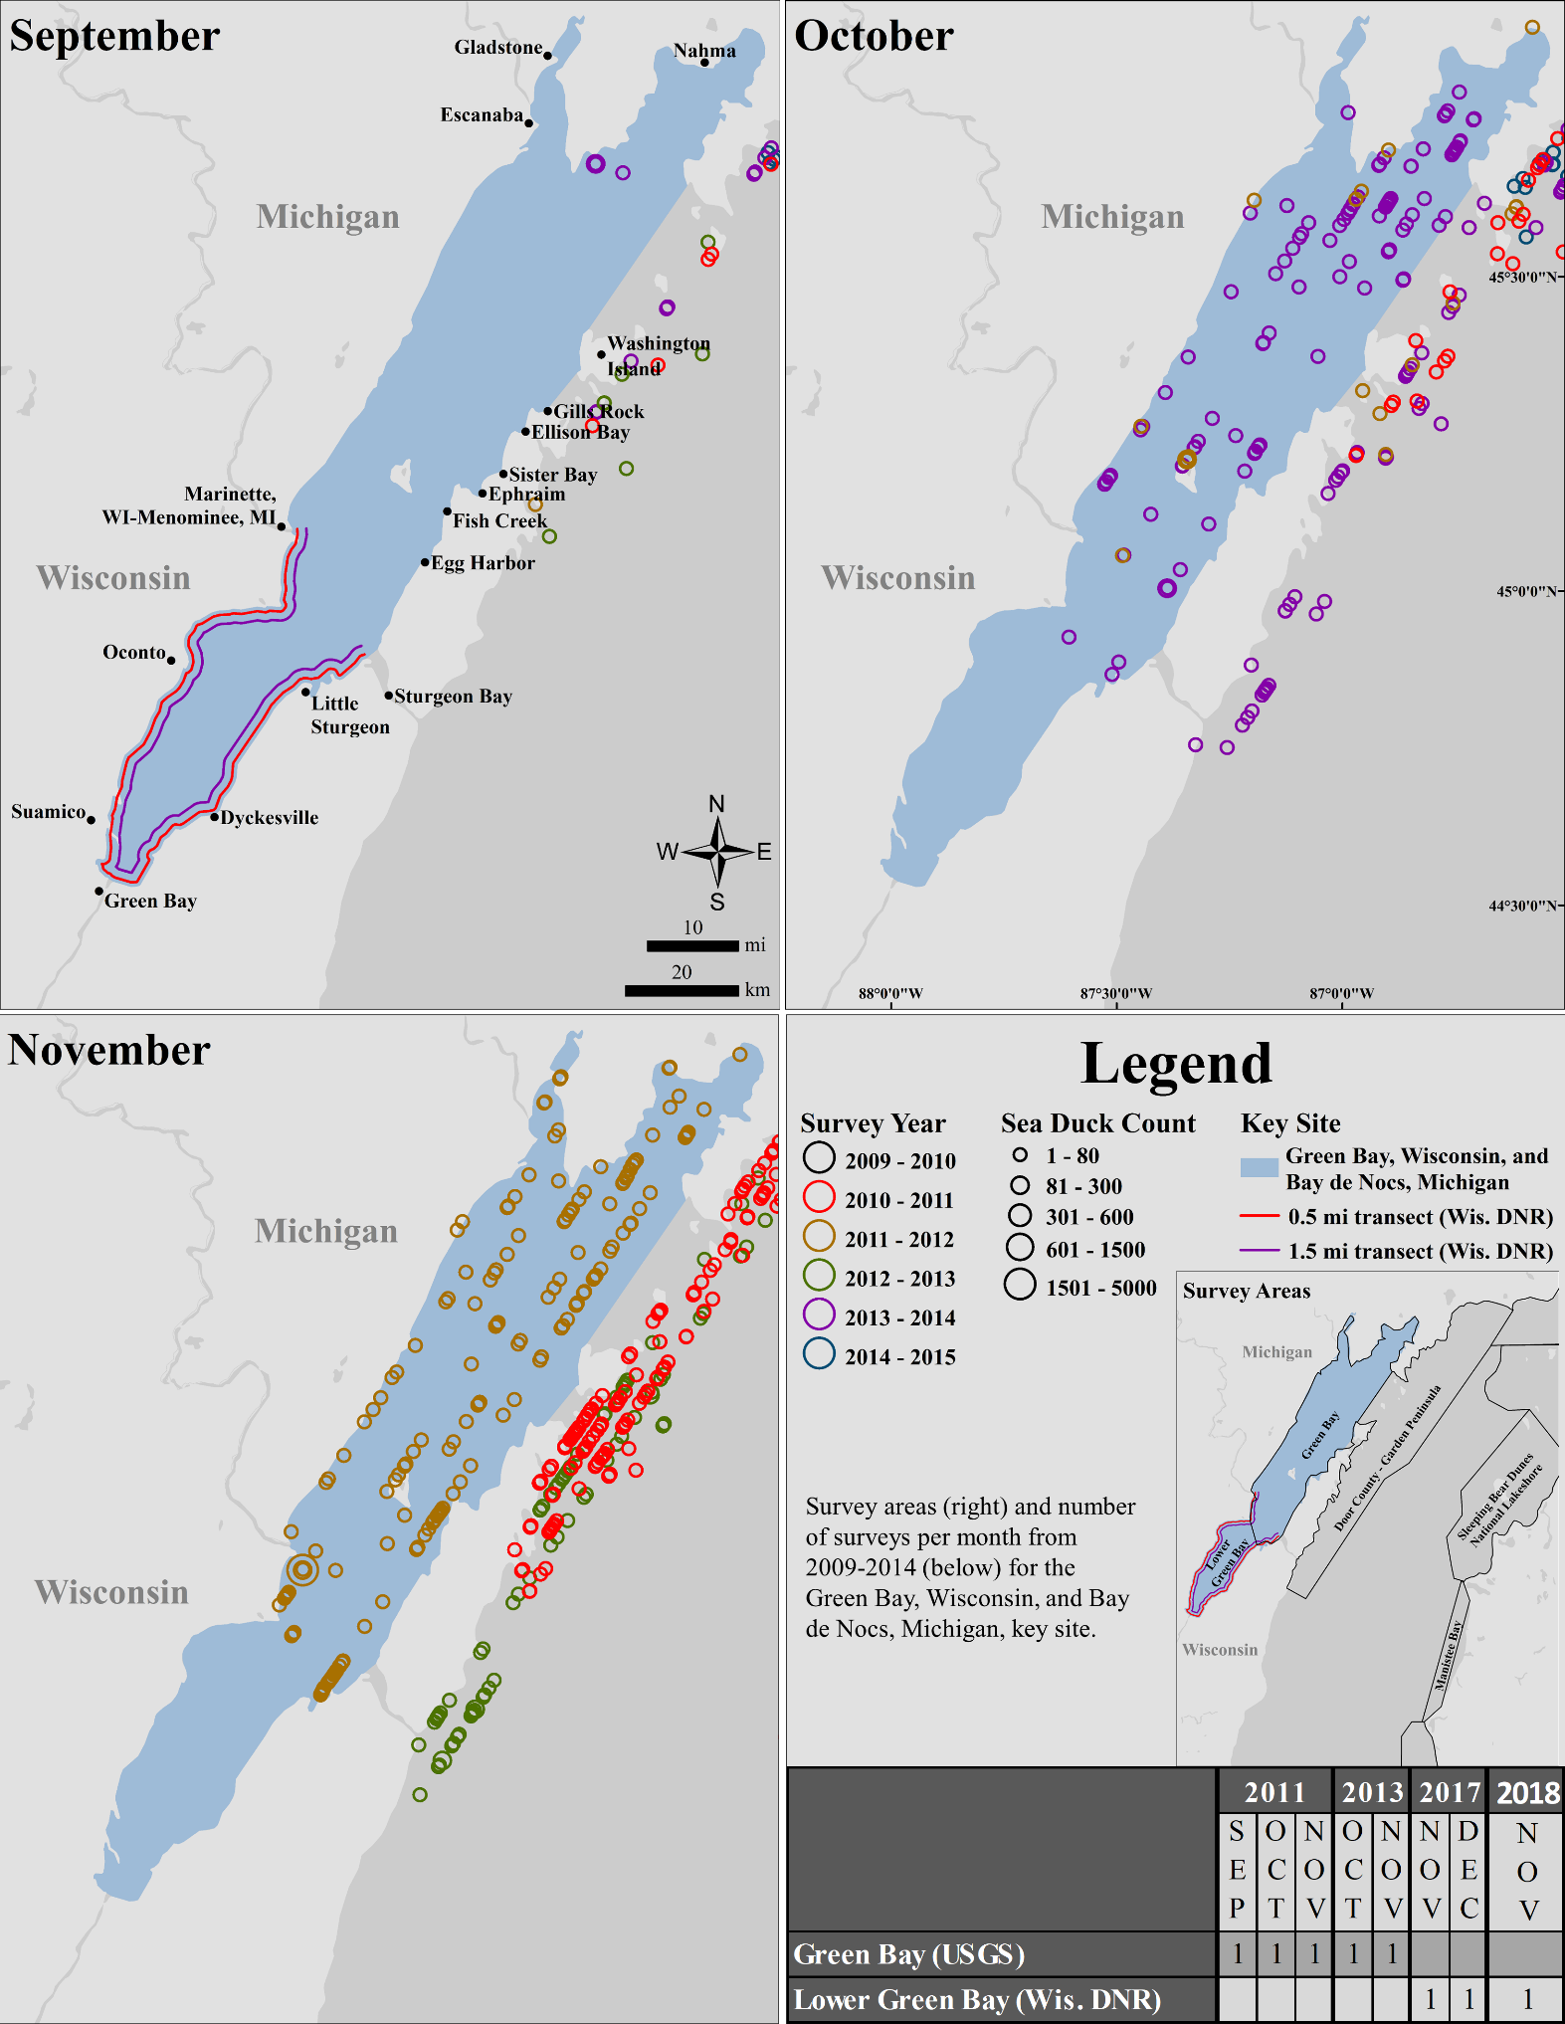

Figure S1. Maps depict sea duck counts from U.S. Geological Survey (USGS) aerial surveys conducted over Lake Michigan during fall (September–November) from 2009–2014 and the Wisconsin Department of Natural Resources (Wis. DNR) transects flown during 2017 and 2018 for the Green Bay, Wisconsin, and Bay de Nocs, Michigan, key site.

1. Any use of trade, firm, or product names is for descriptive purposes only and does not imply endorsement by the U.S. government or Wisconsin state government.