Appendix 1. Distribution and abundance of Long-tailed Ducks along the western Lake Michigan, 2013–2014.

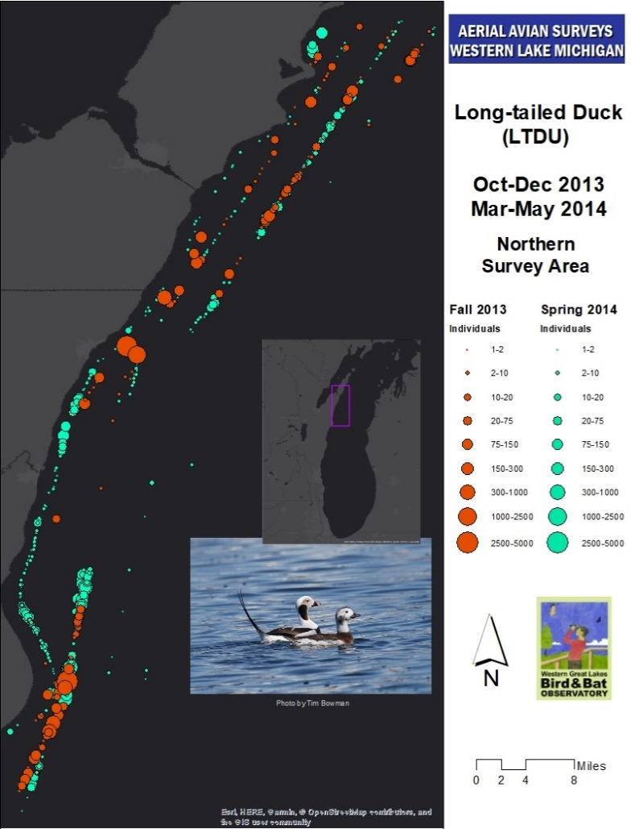

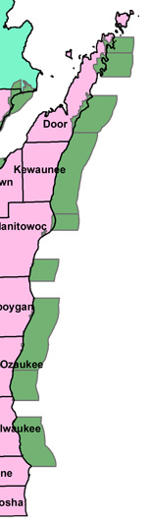Appendix 2. Wisconsin Important Bird Areas on the Western Lake Michigan Shore

Appendix 3. Extensive ice cover in survey area, spring 2014. Photo: Joel Trick.

